25 MW Steam Turbo Generator (STG)

A **turbo generator** is the combination of a [turbine](https://en.wikipedia.org/wiki/Turbine) directly connected to an [electric generator](https://en.wikipedia.org/wiki/Electric_generator) for the generation of [electric power](https://en.wikipedia.org/wiki/Electric_power). Large [steam-powered](https://en.wikipedia.org/wiki/Steam_turbine) turbo generators provide the majority of the world's electricity and are also used by steam-powered [turbo-electric](https://en.wikipedia.org/wiki/Turbo-electric) ships.

Smaller turbo-generators with [gas turbines](https://en.wikipedia.org/wiki/Gas_turbine) are often used as [auxiliary power units](https://en.wikipedia.org/wiki/Auxiliary_power_unit). For base loads [diesel generators](https://en.wikipedia.org/wiki/Diesel_generator) are usually preferred, since they offer better [fuel efficiency](https://en.wikipedia.org/wiki/Fuel_efficiency), but, on the other hand, diesel generators have a lower power density and hence, require more space.

The efficiency of larger gas turbine plants can be enhanced by using a [combined cycle](https://en.wikipedia.org/wiki/Combined_cycle), where the hot [exhaust gases](https://en.wikipedia.org/wiki/Exhaust_gas) are used to generate [steam](https://en.wikipedia.org/wiki/Steam) which drives another turbo generator.

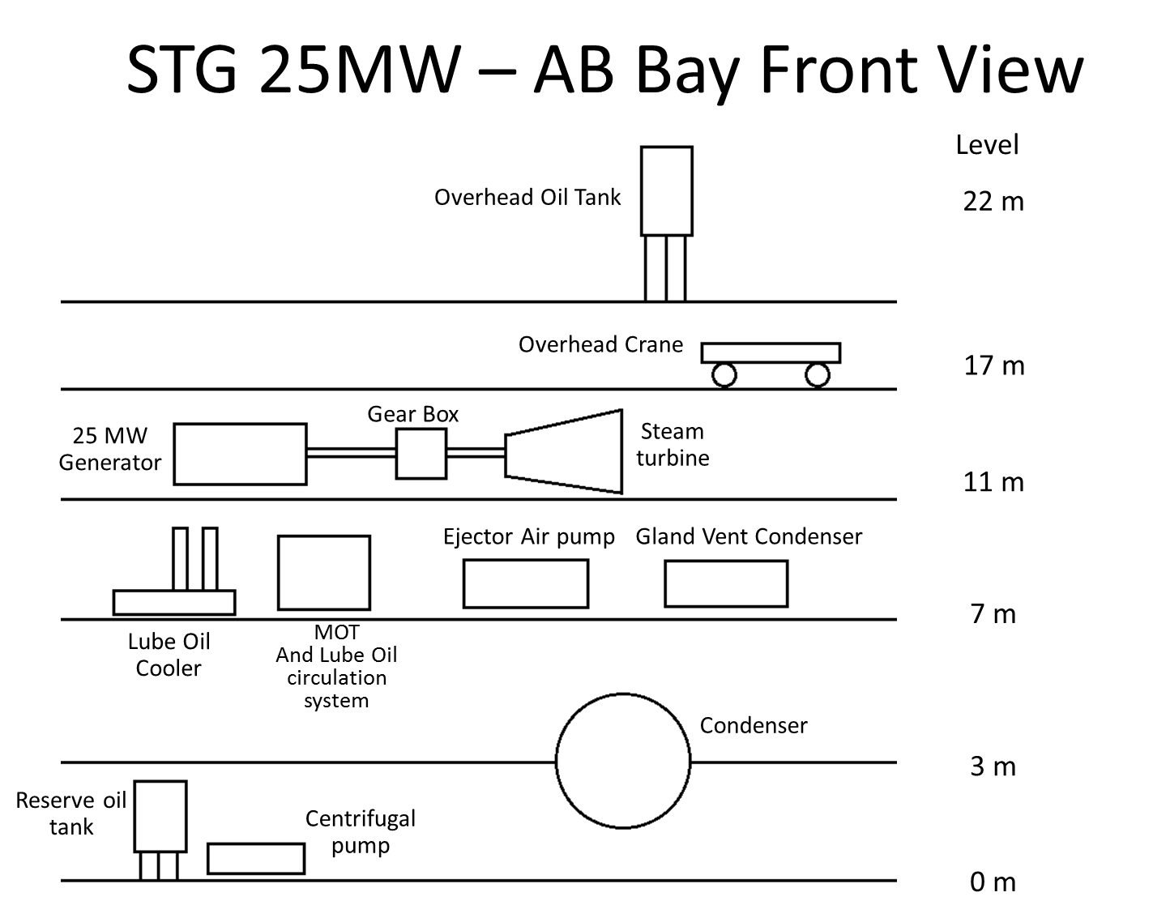

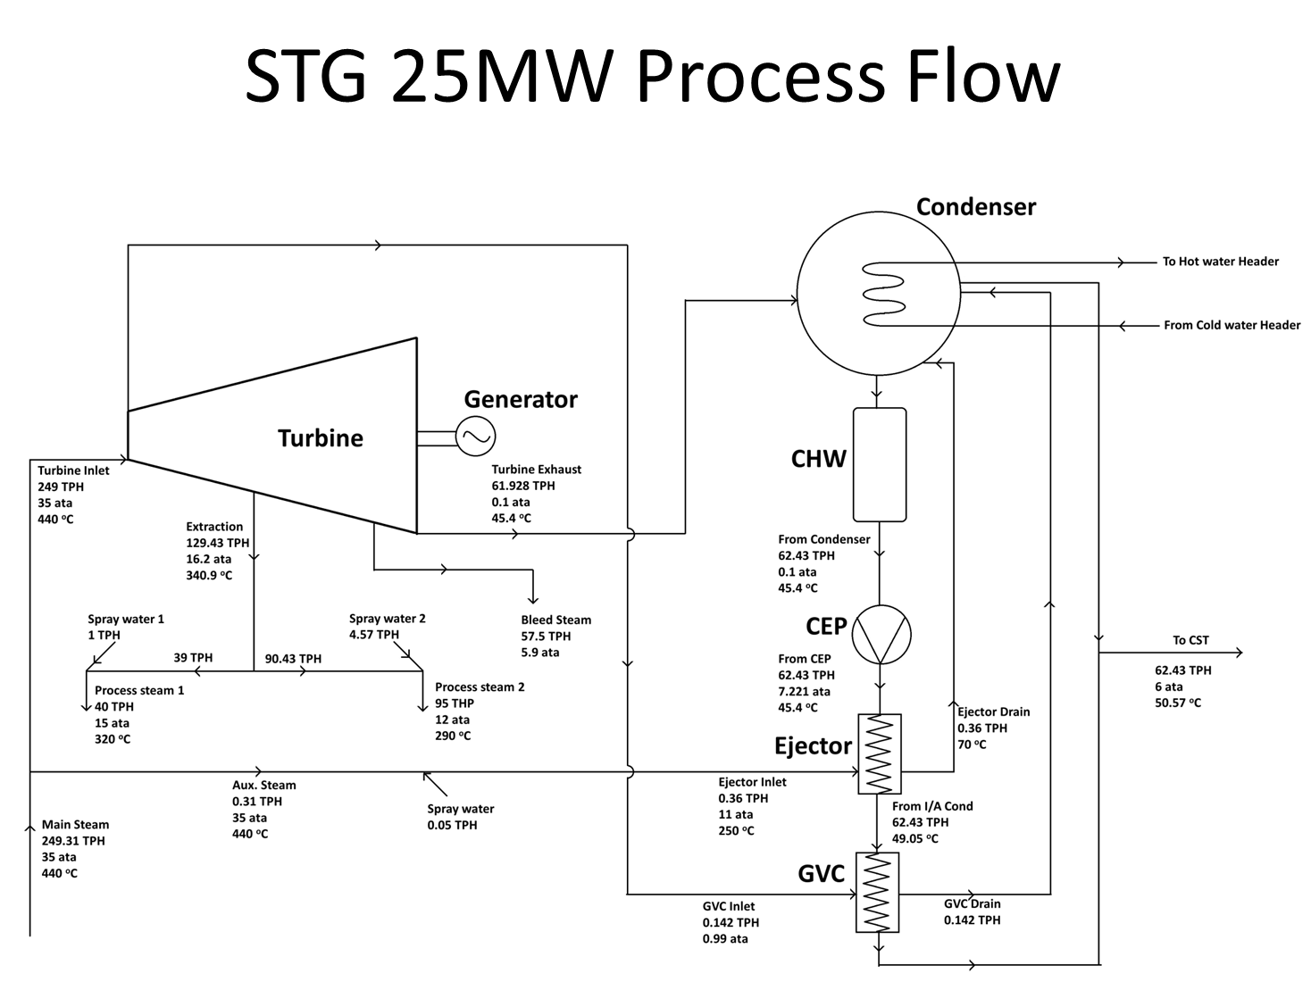

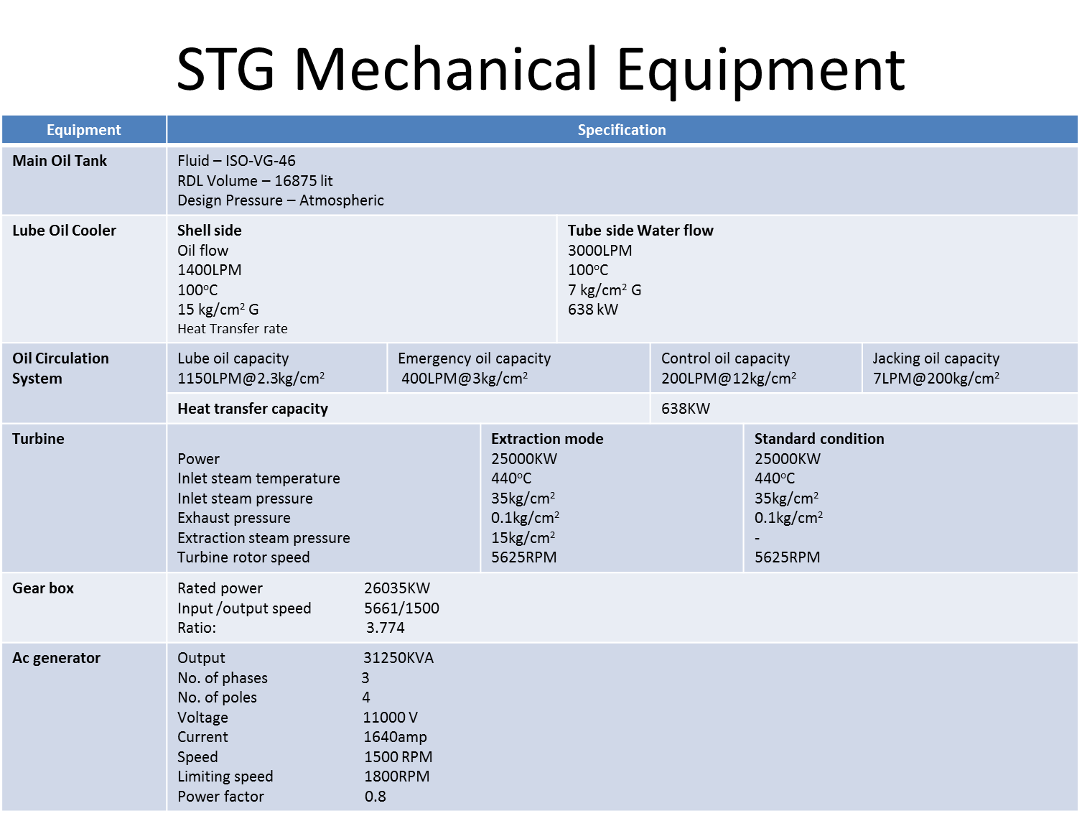

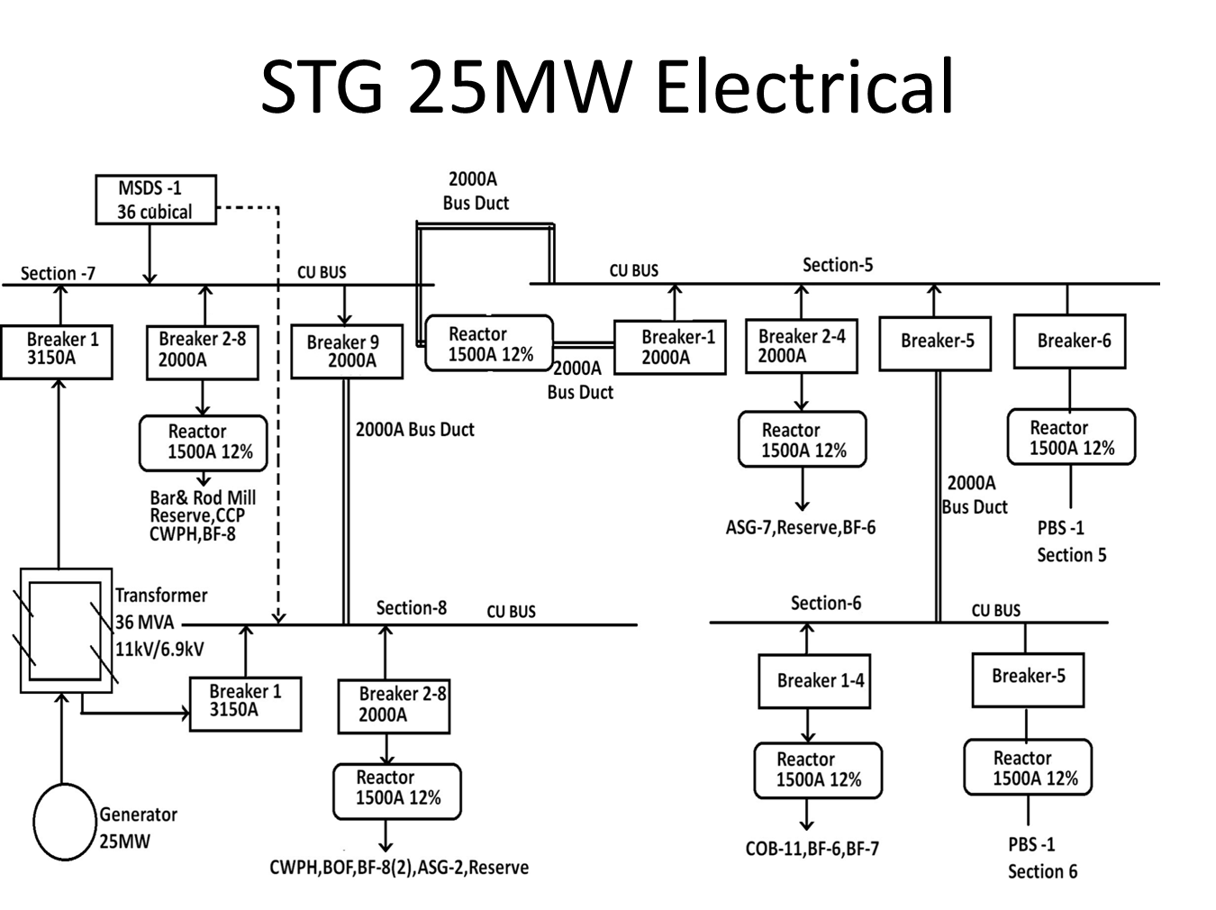

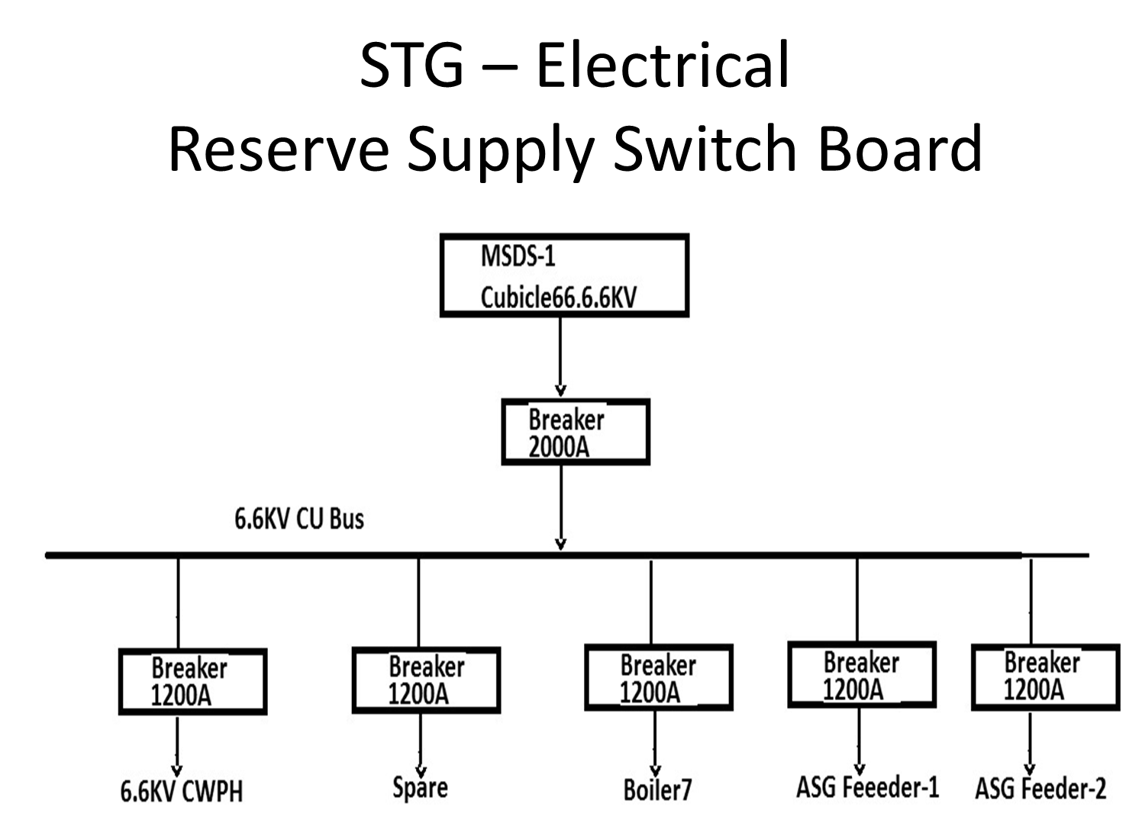

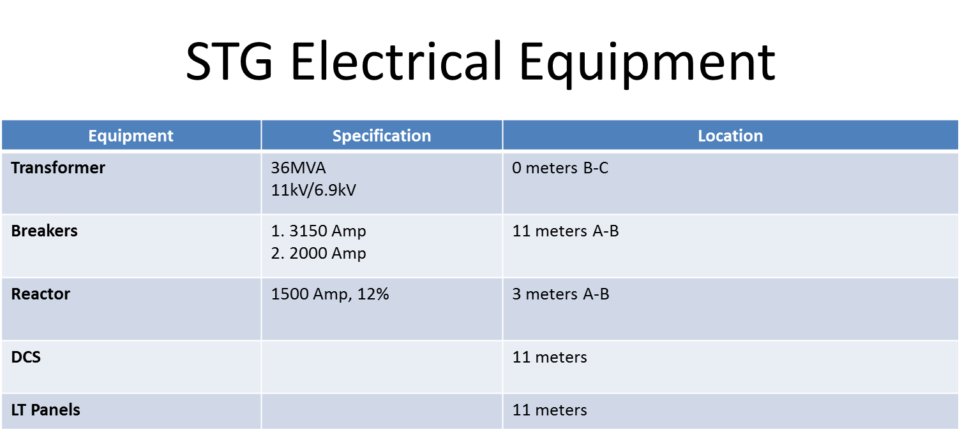

STG Load Calculations



**TECHNICAL DATA SHEET OF AUXILIARY TRANSFORMER**

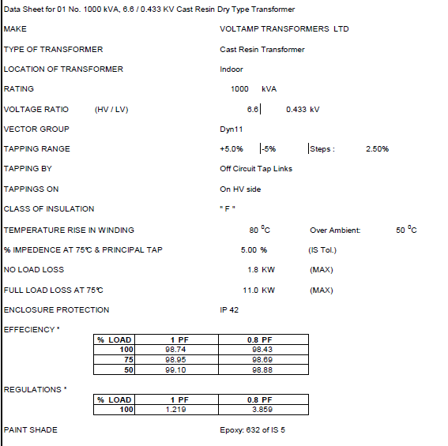

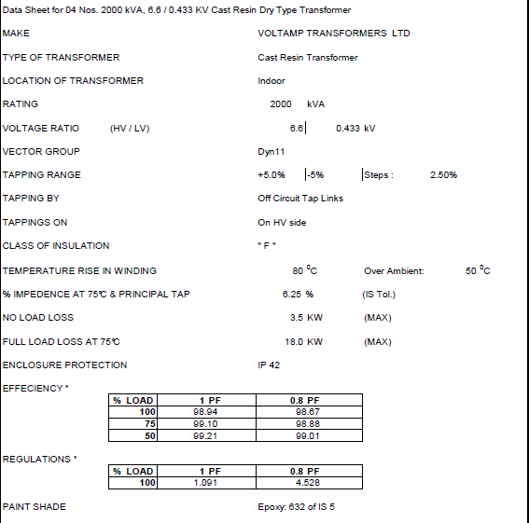

**Approved 25MW STG, ESGB & RSSB SLD**

